**CEN 4010 Principle of Software Engineering, Spring 2018**

**Milestone 3: More Detailed Requirements, Architecture and a Vertical Software Prototype**

*Team Name: Grupo Fivo*

*Team 5*

**Neil Maniquis**

nmaniquis2017@fau.edu

**Noah Leach**

nleach2013@fau.edu

**Diego Segura**

dsegura2015@fau.edu

**George Bechtel**

gbechtel2013@fau.edu

**Franklin Carrillo**

fcarrillo2012@fau.edu

**Date: 3/26/18**

1. Executive Summary:

Perry’s Parts Pavillion Access Center will allow students to access lab equipment and electronic parts with an account created using their Z-number. There will be a database which contains a list of electronic parts available to students in the lab. The admin (Perry) and staff have control over this database. We will also provide a way for students to upload files for laser cutting and 3d printing jobs. This product would be suitable for electronics labs in other academic institutions.

1. Competitive Analysis:

|  |  |  |  |  |  |
| --- | --- | --- | --- | --- | --- |
|  | Shipping | Rentals | Bidding | User Listings | Laser Cutting/3D Printing |
| PPPAC | ✔ | ✔ | ✘ | ✔ | ✔ |
| Amazon | ✔ | ∼ | ✘ | ✔ | ✘ |
| eBay | ✔ | ✘ | ✔ | ✔ | ✘ |
| Craig’s List | ∼ | ✘ | ✘ | ✔ | ✘ |

|  |  |
| --- | --- |
|  | Legend |
| ✔ | Yes |
| ✘ | No |
| ∼ | Somewhat |

Amazon, eBay, and Craig’s List are extremely large online stores that appeal to a mainstream audience will leaving out specialized enthusiasts. Our small, lightweight platform allows us to take laser cutting and 3D printing jobs that other online stores do not. In addition, we have a physical location, allowing us to perform rentals, an impossible feat to perform with a solely online store. Although we are a small store, we still have many of the features of a big online store, such as shipping and allowing users to list their own items for sale. As you would expect, staff and students can list items for sale, with a small fee for using our infrastructure. Our small size will allow individual items to be easier to find, since they aren’t going to be buried in thousands of other listings.

1. Data Definition:

Perry’s Parts Pavillion Access Center – The name of our product.  
Item – Products to be made available to customers.  
Job items – Includes 3d printing , laser cutting, and printed circuit board requests.  
Shopping list – A list of intended items to later purchase.  
Check out – The collection of items about to be purchased.  
Homepage – The introductory page of the website.  
Kits – Several related items sold as a bundle for an overall reduced price.  
Rental – Tools available for rent.  
Z-number – The primary key used to identify student user accounts. Each student at FAU has previously had one assigned.  
EE 96 Room 205 – The location of electronics parts, tools, 3d printer, laser cutter, and desk.  
Cost – The average acquisition dollar amount for one unit. Refers to the average value of the item.  
Price – The dollar amount for one unit when selling.   
Retail – Price for individuals.  
Bulk – Price for large orders. May be used for individuals or groups  
Jobber – Price for middleman, such as other departments.

1. Overview, Scenarios and Use Cases:

Customers can:

1. visit the website

2. search for an item by browsing through categories

3. read product information

4. add items to the shopping list

5. select quantity of the items to be ordered

6. check out

7. create an account or log in

8. receive a confirmation of the order

9. request for new items

10. request job items

11. request rentals

Staff can:

1. locate inventory in store,

2. add vendor information,

3. add item information,

4. create kits,

5. update inventory,

6. complete orders,

7. track rentals,

8. view customer accounts and transactions

Admin can:

1. approve items

2. edit customer accounts

3. add and edit staff accounts

1. High-Level Functional Requirements

Priority Level:

1 - Must Have

2 - Desired

3 - Opportunistic as Defined in the Class

Priority: 1 A GUI for the user to use Perry’s Parts Pavillion Access Center.

Priority: 1 A database with user accounts (student, staff, admin), a catalog of all the electronic parts available to students

Priority: 2 List of tools available for rental, and laser cutting/3d printing jobs.

Priority: 2 Ability of students to request tickets for advice/troubleshooting (mentoring invoice) and orders.

Priority: 2 Support for barcode scanner used by staff and admin for adding items to the catalog, checking out items, and distributing kits to students.

1. List of Non-Functional Requirements

Ability to go to any item page from the homepage within 1 minute

Ability to create a new user account under 5 minutes

Ability to add a new item for sale under 8 minutes

Ability to update the inventory of 10 items in under 5 minutes

Passwords are not stored in plaintext

Usability of website for customer on a mobile device should be within 1 minute of desktop experience

1. High-Level System Architecture and Database Organization

Database class diagram

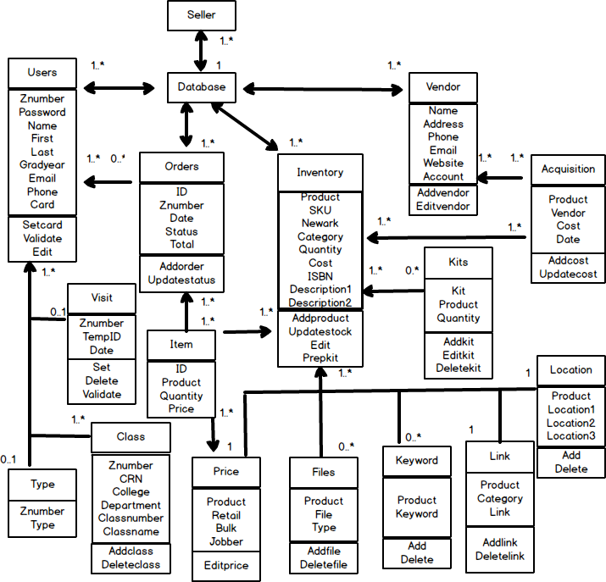

**Database tables:**

Users(Name varchar(20), First varchar(25), Last varchar(25), Znumber int(8), Email varchar(50), Password varchar(275), Phone varchar(20), Gradyear int(4), Card varchar(25), Extra1 varchar(250), Extra2 varchar(250), Extra3 varchar(250))

Type(Znumber int(8), Type varchar(10))

Visit(Znumber int(8), TempID varchar(10), Date varchar(25))

Class(CRN int(5), College varchar(5), Department varchar(5), Class varchar(5), Classnumber varchar(5), Classname varchar(50))

Order(ID int(8), Znumber int(8), Date varchar(20), Status varchar(15), Total decimal(19,4), Extra varchar(250))

Item(ID int(8), Product varchar(75), Quantity int(8), Price decimal(19,4))

Vendors(Name varchar(50), Address varchar(250), Phone varchar(20), Email varchar(50), Website varchar(50), Account varchar(50), Extra1 varchar(250), Extra2 varchar(250), Extra3 varchar(250))

Price(Product varchar(75), Retail decimal(19,4), Bulk decimal(19,4), Jobber decimal(19,4))

Inventory(Product varchar(75), SKU varchar(25), Newark varchar(25), Category varchar(25), Cost decimal(19,4), Quantity int(6), Descriptionshort varchar(350), Descriptionlong varchar(900), ISBN varchar(25), Extra1 varchar(250), Extra2 varchar(250), Extra3 varchar(250))

Location(Product varchar(75), Location1 varchar(25), Location2 varchar(25), Location3 varchar(25))

Kit(Product varchar(75), Kit varchar(25), Quantity int(8))

Files(Product varchar(75), File varchar(200), Type varchar(25))

Acquisition(Product varchar(75), Vendor varchar(25), Cost decimal(19,4), Date varchar(20))

Keyword(Product varchar(75), Keyword varchar(25))

Link(Product varchar(75), Category varchar(25), Link varchar(250))

**Media storage:** in file system

Image and PDF files will be stored in their corresponding item folder. The database will contain url for files

**Keyword search:**

Each keyword and product pair will occupy a row on the Keyword table. This allows for a variable amount of keywords for a single product.

Keyword search is done by searching the table for the matching word (SELECT Products from Keyword WHERE Keyword = keyword). The results will be used individually to find the links in the Link table.

Software/Tools:

1. Brackets

2. Putty

3. Filezilla

4. Git Gui/Git bash

5. LAMP

Languages:

1. HTML/CSS
2. Javascript
3. PHP
4. MySQL

Supported browsers:

1. Firefox
2. Chrome
3. Safari
4. Microsoft Edge

1. High-Level UML Diagrams

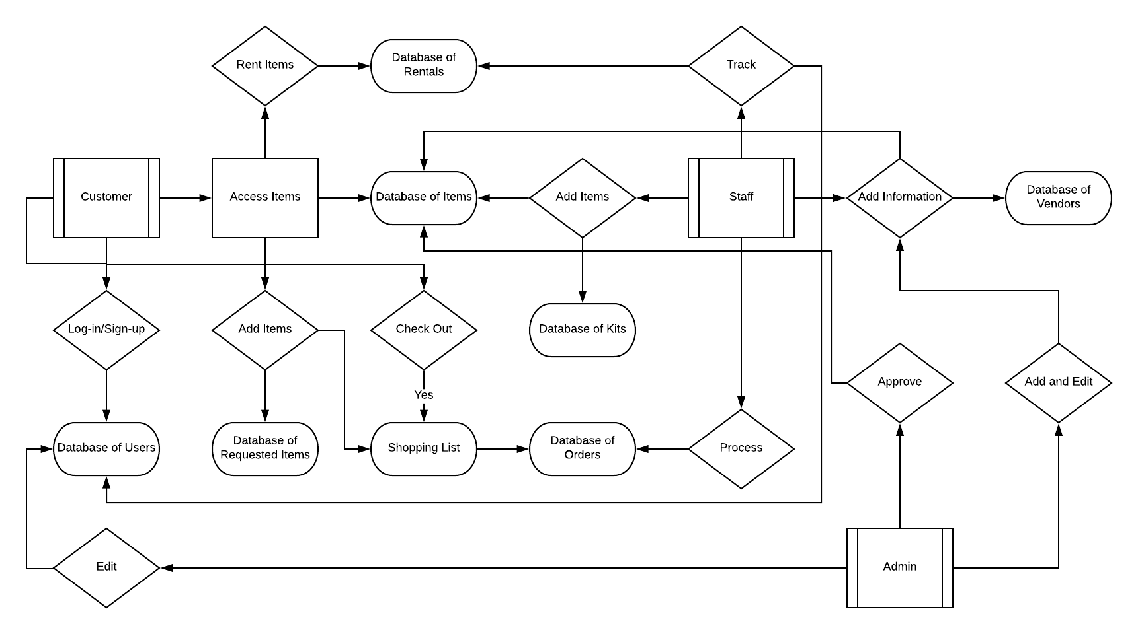

1. Key Risks

1. Skills risks: 3 out of 5 team members have no previous experience with web development. Only 1 has experience with backend.

2. Schedule risks: Our priority 1 requirements should be able to be implemented. Likely, our priority 2 requirements, and less likely, priority 3.

3. Technical risks: The CSV file has products with % in the name. This generates a URL that results in a bad request.

Item pages are created through PHP. There is a possibility for malicious code to be saved to the server.

4. Teamwork risks: All of our team members are distance learning students, meaning we do not meet physically on a daily basis.

5. Legal/content risks: We do not expect to encounter any legal or content risks.

|  |  |
| --- | --- |
| **Date** | **Changes** |
| 2/19/18 | Original proposal |
| 3/16/18 | Created history table, described database tables, added definitions on price |
| 3/17/18 | Added database diagram made using balsamiq, updated tables |
| 3/25/18 | Updated system architecture |
|  |  |
|  |  |
|  |  |